How to download minikube and kubectl

To create a new Kubernetes cluster using minikube with a name Jayveer

And number of node is use 2

To install kubectl

curl -LO [https://dl.k8s.io/release/**$(**curl -L -s https://dl.k8s.io/release/stable.txt**)**/bin/linux/amd64/kubectl](https://dl.k8s.io/release/$(curl%20-L%20-s%20https://dl.k8s.io/release/stable.txt)/bin/linux/amd64/kubectl)

we use this command

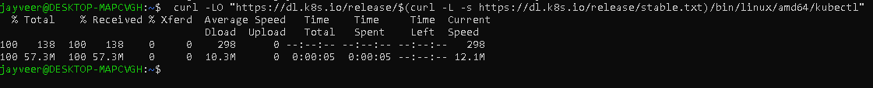

sudo install -o root -g root -m 0755 kubectl /usr/local/bin/kubectl

kubectl version –client



Name jayveer is our master node cluster

And jayveer-m02 name is our work node cluster

To stop clusters use these commands

minikube stop -p jayveer

minikube stop -p jayveer-m02

To check all minikube cluster

* minikube profile list

K8S Dashboard

(install dashboard and access the dashboard)

To create new cluster

Minikube start –nodes

* minikube dashboard

to enabling dashboard

<http://127.0.0.1:38439/api/v1/namespaces/kubernetes-dashboard/services/http:kubernetes-dashboard:/proxy/>

using this url I am seen my dashboard

